**LABORATORY PROGRAM – 6**

Create a package CIE which has two classes- Student and Internals. The class Personal has members like usn, name, sem. The class internals has an array that stores the internal marks scored in five courses of the current semester of the student. Create another package SEE which has the class External which is a derived class of Student. This class has an array that stores the SEE marks scored in five courses of the current semester of the student. Import the two packages in a file that declares the final marks of n students in all five courses.

**OBSERVATION :**

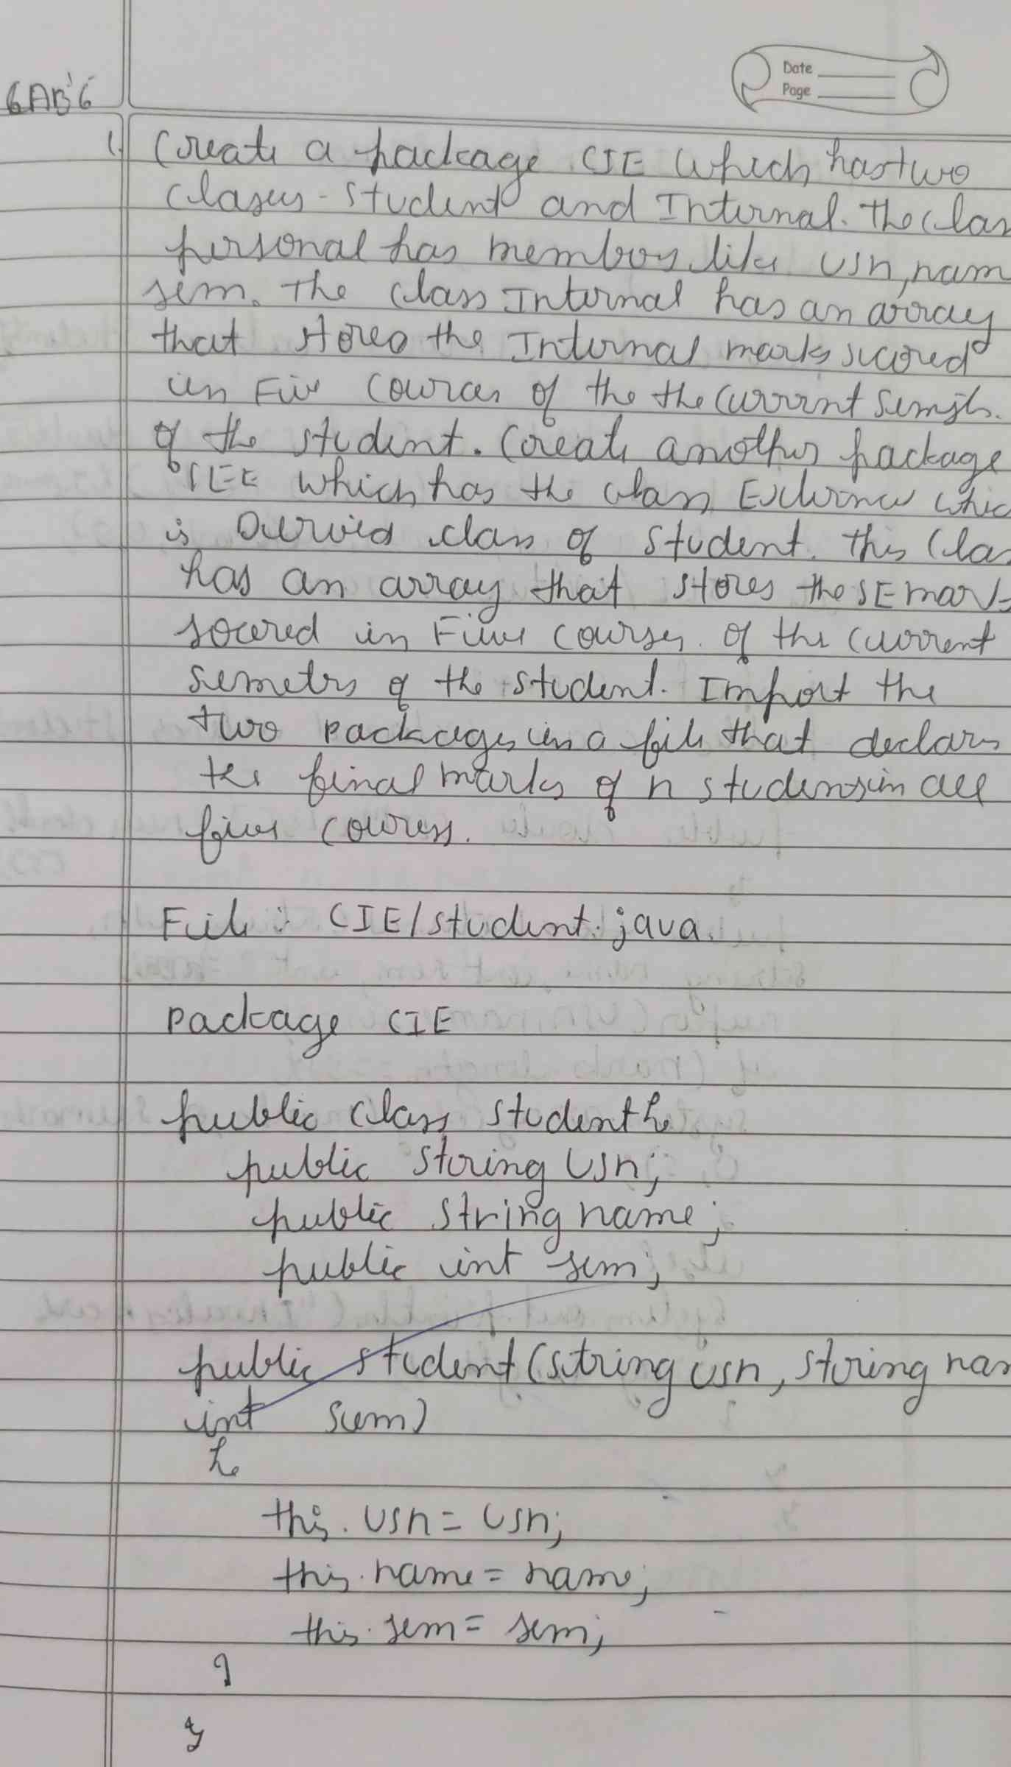

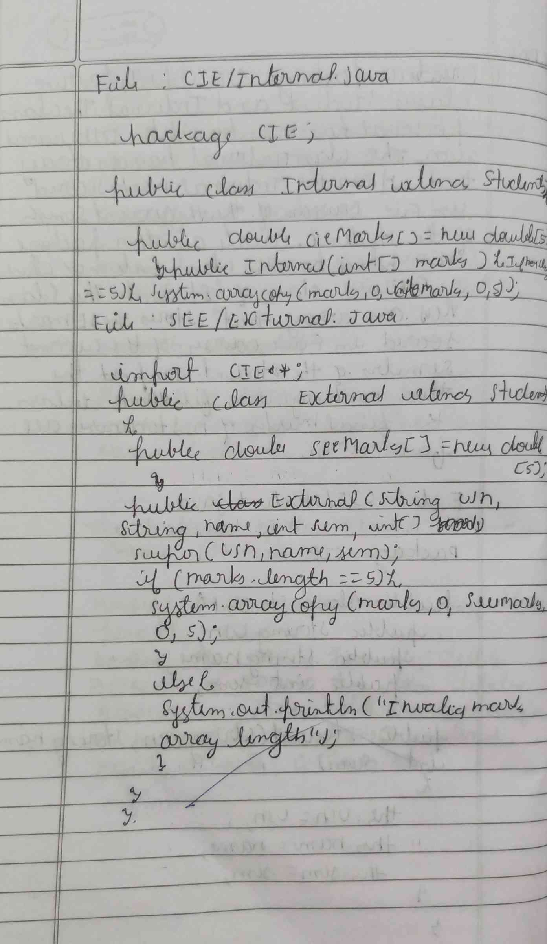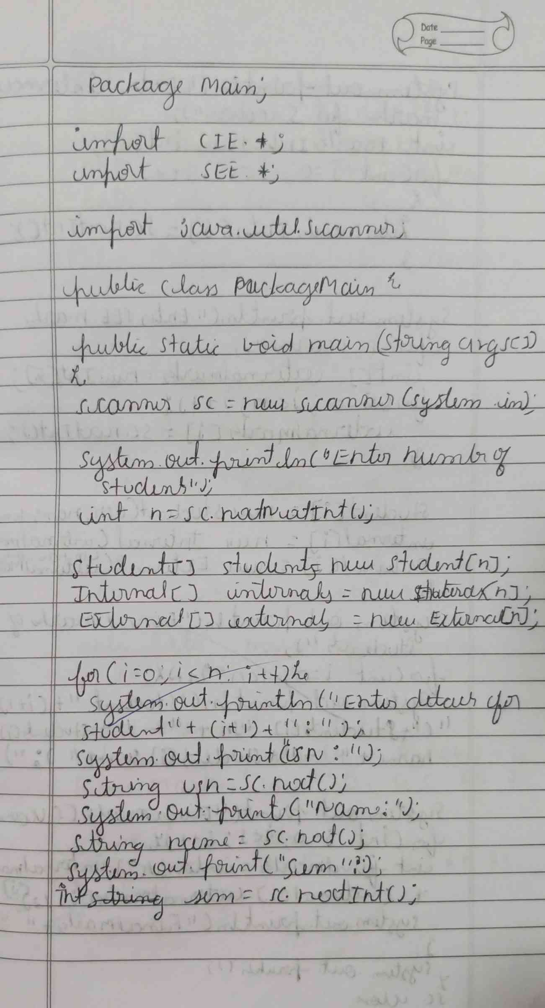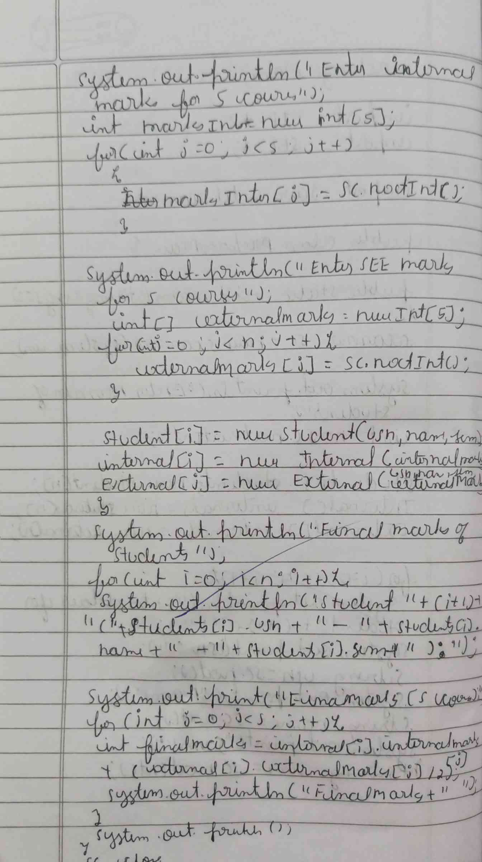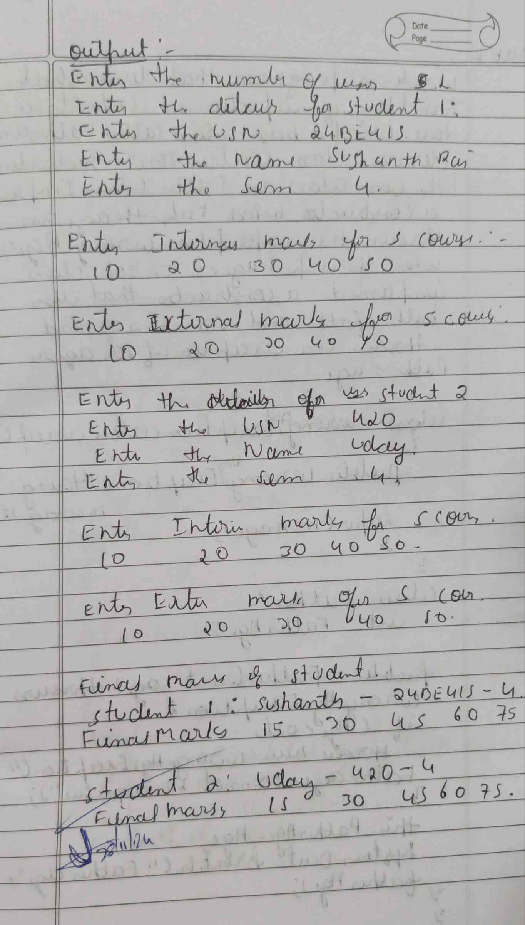

**CODE :**

**File : CIE/Student.java**

**package cie;**

**public class Student {**

**public String usn;**

**public String name;**

**public int sem;**

**public Student(String usn, String name, int sem) {**

**this.usn = usn;**

**this.name = name;**

**this.sem = sem;**

**}**

**}**

**File : CIE/Internal.java**

**package cie;**

**public class Internals {**

**public int[] internalMarks = new int[5];**

**public Internals(int[] marks) {**

**if (marks.length == 5) {**

**System.arraycopy(marks, 0, internalMarks, 0, 5);**

**} else {**

**System.out.println("Error: Please provide marks for exactly 5 courses.");**

**}**

**}**

**}**

**File : SEE/External.java**

**package see;**

**import cie.Student;**

**public class External extends Student {**

**public int[] externalMarks = new int[5];**

**public External(String usn, String name, int sem, int[] marks) {**

**super(usn, name, sem);**

**if (marks.length == 5) {**

**System.arraycopy(marks, 0, externalMarks, 0, 5);**

**} else {**

**System.out.println("Error: Please provide marks for exactly 5 courses.");**

**}**

**}**

**}**

**File : FinalMarrks.java**

**import cie.*;**

**import see.*;**

**import java.util.Scanner;**

**public class FinalMarks {**

**public static void main(String[] args) {**

**Scanner sc = new Scanner(System.in);**

**System.out.print("Enter number of students: ");**

**int n = sc.nextInt();**

**Student[] students = new Student[n];**

**Internals[] internals = new Internals[n];**

**External[] externals = new External[n];**

**for (int i = 0; i < n; i++) {**

**System.out.println("Enter details for student " + (i + 1) + ":");**

**System.out.print("USN: ");**

**String usn = sc.next();**

**System.out.print("Name: ");**

**String name = sc.next();**

**System.out.print("Semester: ");**

**int sem = sc.nextInt();**

**System.out.println("Enter internal marks for 5 courses:");**

**int[] internalMarks = new int[5];**

**for (int j = 0; j < 5; j++) {**

**internalMarks[j] = sc.nextInt();**

**}**

**System.out.println("Enter SEE marks for 5 courses:");**

**int[] externalMarks = new int[5];**

**for (int j = 0; j < 5; j++) {**

**externalMarks[j] = sc.nextInt();**

**}**

**students[i] = new Student(usn, name, sem);**

**internals[i] = new Internals(internalMarks);**

**externals[i] = new External(usn, name, sem, externalMarks);**

**}**

**System.out.println("\nFinal Marks of Students:");**

**for (int i = 0; i < n; i++) {**

**System.out.println("Student: " + students[i].name + " (USN: " + students[i].usn + ")");**

**for (int j = 0; j < 5; j++) {**

**int finalMarks = internals[i].internalMarks[j] + externals[i].externalMarks[j] / 2;**

**System.out.println("Course " + (j + 1) + ": " + finalMarks);**

**}**

**}**

**sc.close();**

**}**

**}**

**OUTPUT :**

